**Museum**

**A screenshot of a social media post

Description generated with very high confidence**

**Home Page:**

* User can go to another pages using the navigation bar.
* If the user is registered the he/she can login using the login module.
* If the user is not registered the he/she can register going to the registration page.
* Can search the site using the search bar.

A screenshot of a social media post

Description generated with very high confidence

A screenshot of a social media post

Description generated with very high confidence

**Registration Page:**

* This is the registration page.
* User can register giving his/her name, username, password, email.

A screenshot of a social media post

Description generated with very high confidence

A screenshot of a social media post

Description generated with very high confidence

**Museum’s goal:**

* In this page the goal of the museum is described.

A screenshot of a social media post

Description generated with very high confidence

**Museum’s History:**

* The history of the museum is described here.

A screenshot of a social media post

Description generated with very high confidence

A screenshot of a social media post

Description generated with very high confidence

**Mission and Vision:**

* Mission and vision of the museum is described here.

A screen shot of a social media post

Description generated with high confidence

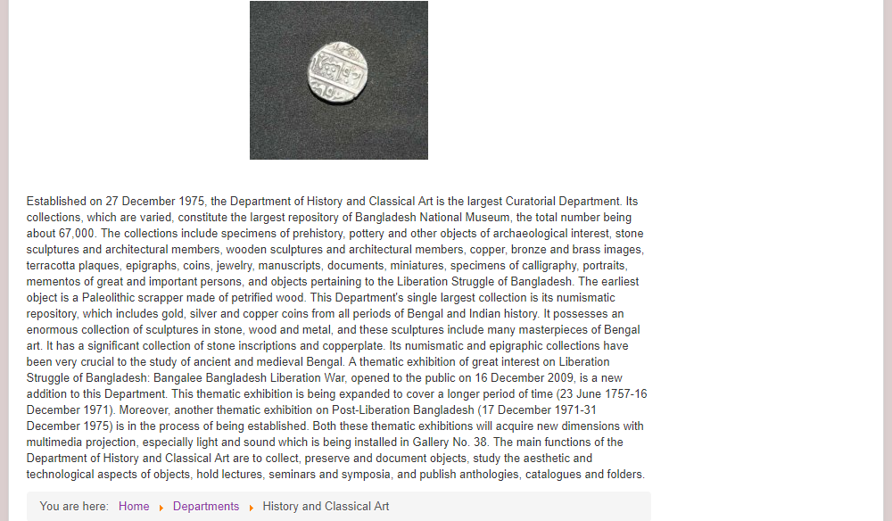

**History and Classical Art:**

* Gallery of history and classical art.
* Click an image to zoom it and watch slide show.
* Description of history and classical art.

A screenshot of a cell phone

Description generated with very high confidence

**Ethnography and Decorative Art:**

* Gallery of ethnography and classical art.
* Click an image to zoom it and watch slide show.
* Description of ethnography and classical art.

A screenshot of a social media post

Description generated with very high confidence

**Natural History:**

* Gallery of natural history.
* Click an image to zoom it and watch slide show.
* Description of natural history.

**A screenshot of a social media post

Description generated with very high confidence**

**Administration, Finance and Security:**

* Administration, finance and security of the museum is described here.

A screenshot of a cell phone

Description generated with very high confidence

**Visiting Hours and Entry Fees:**

* Visiting hours is given.
* Entry fees for different people is given.